We indicate that the paper must be WRITTEN according to the GUIDELINES PRESENTED IN THE BLUE TEXTS. All text in COLOR BLUE must be subsequently ERASED.
- The information presented in text in COLOR BLACK MUST BE MAINTAINED in the final version of the paper and MUST NOT BE CHANGED, as they are mandatory elements.
- The minimum size of PAPER IS LIMITED TO FIVE PAGES AND THE MAXIMUM TO TEN PAGES, including tables and figures.
- The standard page format corresponds to A4 SHEET, with LEFT, UPPER, RIGHT AND LOWER MARGINS with 2CM.
- The text must be written with 1,5 SPACING IN SINGLE COLUMN, using Times New Roman font, size 12. Except as indicated in the blue guidelines.
- The authors SHOULD NOT CREATE A PAGE (COVER) TO INCLUDE THE PRE-TEXTUAL ELEMENTS (title of the paper, subtitle of the paper, name of the authors, company name, abstracts of the paper, keywords). As the system will create and include these items automatically and already in the correct format.
- The authors SHOULD NOT INCLUDE THE REFERENCES, annexes and appendices. As the system will create and include these items automatically and already in the correct format.
- Enter the paper title (even pages) and authors name (odd pages) information only in the fields marked in red in the header. keeping the format used in the guideline.

(After deleting all the text in blue, leave NO spacing above the introduction title)

- Introduction (mandatory section. Do not change title of this section) (Font Times New Roman, 12, Bold, Left-aligned)

INCLUDE INTRODUCTION TEXT: in the introduction, the authors must present and delimit the subject matter, the research objectives and other elements necessary to situate the theme of the paper. (Use Times New Roman font, 12, Justified alignment. Every beginning of paragraph must have an indent of 1.0 cm.)

- Include title of the second section (Font: Times New Roman, 12, Bold, Left-aligned, black color font. Capital letters should only be used in in the first letter of the title, in the first letter of proper names and in the letters of acronyms.)

INCLUDE THEME DEVELOPMENT TEXT (Use Times New Roman Font, 12, Justified alignment. Every beginning of paragraph must be indented by 1.0 cm). The titles of the following sections and subsections must be preceded by increasing numbers, in Arabic numerals, separated and terminated by a period. (for example: 2.1. 2.2. 2.2.1. 2.2.2, 3., 3.1., 3.1.1., 3.1.2, 3.2., 3.2.1., 3.3. 4.,
4.1., 4.2.) . EXAMPLE:

(After deleting all the text in blue, leave TWO spaces above the title of the other sections)
  - Include title of this subsection (Font Times New Roman, 12, bold, left alignment, black color font)

INCLUDE TEXT. (Use Times New Roman font, 12, Justified alignment. Every beginning of paragraph must have an indent of 1.0 cm.)

INCLUSION OF TABLES, FIGURES, DRAWING, SCHEME, FLOWCHART, PHOTOGRAPHY, CHART, MAP, ORGANIZATION CHART, PLANT, FRAME, PORTRAIT, FIGURE, IMAGE, AMONG OTHERS.

- Whatever the type of illustration, it must be preceded by its designative word (Drawing, Scheme, Flowchart, Photography, Chart, Map, Organization Chart, Plan, Frame, Portrait, Figure, Image, among others), followed by an increasing number in Arabic numerals, dash and title created by the author.
- Immediately after the illustration, must indicate the font consulted ( mandatory element , even if it is the author's own production ). If any, captions, notes and other necessary information may be included after the source is indicated. All these information must follow the margin in the illustration.
- The illustration must be cited in the text and inserted as close as possible to the passage to which it refers.

EXAMPLE:

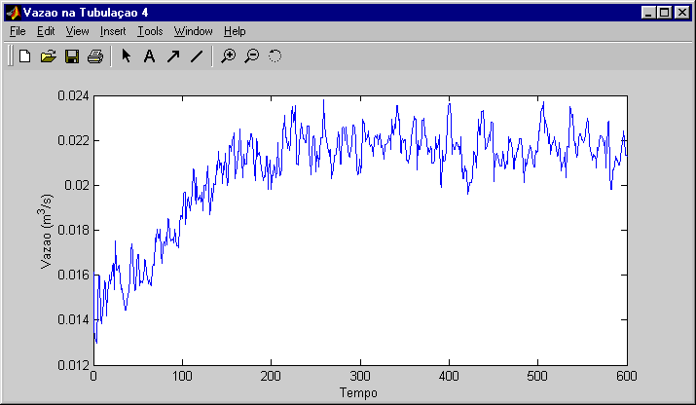
Figure 1 - Program window (Times New Roman, 10, centralized)

Source: produced by the author. (Times New Roman, 10, aligned to the margin of the illustration)

- Each table must be centralized, being referenced in the text as, for example: "The problem data is present in Table 1 ...".
- The information inside the tables must also be written in Times New Roman, size 10.
- The table border style to be used is shown in the following example.

EXAMPLE:

Table 1 - Comparison between approaches (Use Times New Roman font, 10, Centralized)
Model | Final Pressure (MPa) | Pressure drop (MPa)
Strict Integration | 3,1634 | 2,3106
Adjusted Parameters | 3,1756 | 2,2984

Source: produced by the author. (Use Times New Roman font, 10, aligned to the margin of the table)

INCLUSION OF EQUATIONS

- Equations must be aligned to the left.
- The font size of the equations must be compatible with the text.
- The equations must be numbered with Arabic numerals, with the number aligned to the right in parentheses.
- When the equations are cited throughout the text, the following standard should be adopted: "... according to Equation 1 ...".

EXAMPLE:

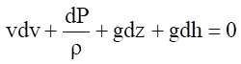 (1)

QUOTES TO OTHER TEXTS

DIRECT QUOTES: When the author quotes an argument (text) using the same words as the author of the idea.
- It must be enclosed in quotation marks, indicating at the end of the excerpt the surname of the original authors and the year of publication BETWEEN PARENTHESES AS INDICATED IN TABLE 2 below.

- Direct quotations that exceed 3 lines should be indented 4 cm to the right, that is, between the left margin and the text, without using quotation marks, with font 10 and single spacing.

EXAMPLE:
excerpt from another text excerpt from another text excerpt from another text excerpt from another text excerpt from another text excerpt from another text t excerpt from another text excerpt from another text excerpt from another text excerpt from another text excerpt from another text. (Sousa, 2018)

INDIRECT QUOTES: quotes from the same idea from another author, but modifying the words of the original text.
- The name of the cited author must be indicated in the text followed by the year of publication of the original work in parentheses. That is, the author's name must not be in parentheses, as indicated in the table below.

Table 2 - Ways to describe authorship of quotes

Types of quotes | First indirect  quote | Subsequent  quotes | First direct  quote | Subsequent  quotes
One author | Hudson (1999) | Hudson (1999) | (Hudson, 1999) | (Hudson,1999)
Two authors | Franco and Marra | Franco and Marra | (Franco and  Marra, 2001) | (Franco and  Marra, 2001)
Three, four and five authors | Oliveira, Chieregato, Perez and Gomes  (2002) | Oliveira et al (2002) | (Oliveira, Chieregato, Perez & Gomes, 2002) | (Oliveira et al., 2002)
Six or more  authors | Ford et al (2003) | Ford et al (2003) | (Ford et al., 2002) | (Ford et al.,  2002)
Entity author / individual | Brazilian Institute  of Corporate Governance (IBGC) (2014) | IBGC (2014) | (Brazilian Institute of Corporate Governance  [IBGC], 2014) | (IBGC, 2014)
Entity author  / group | Federal Accounting Council (CFC) and Financial Research Foundation (FIPECAFI) (1994) | CFC and  FIPECAFI (1994) | (Federal Accounting Council [CFC] and Financial Research Foundation [FIPECAFI], 1994) | (CFC &  FIPECAFI, 1994)
Font: Associação Nacional de Pós-Graduação e Pesquisa em Administração (ANPAD)

- Final Remarks (mandatory section, but the title can be adjusted) (Font Times New Roman, 12, Bold, Left-aligned)

INCLUDE FINAL REMARKS TEXT. (Use Times New Roman font, 12, Justified alignment . Every beginning of paragraph must have an indent of 1.0 cm)

Acknowledgments (Optional section. Use Times New Roman font, size 12, Bold, Left-aligned)

INCLUDE TEXT (Times New Roman font, 12, Justified alignment). (every beginning of paragraph must have an indent of 1.0 cm.)
Authors must indicate in this section, the eventual sponsors of this research. Other acknowledgments are freely chosen.

> ATTENTION: authors SHOULD NOT INCLUDE BIBLIOGRAPHICAL
REFERENCES IN THIS DOCUMENT. This document should only contain the introduction, development, final remarks and acknowledgments of the paper. Other parts will be included automatically by the systems.

